**UNIT-I**

**Introduction to Information Retrieval Systems**

* There is a potential for confusion in the understanding of the differences between Database Management Systems (DBMS) and Information Retrieval Systems.
* The importance of the differences lies in the inability of a database management system to provide the functions needed to process “information.”

Information Retrieval is an activity of obtaining relevant documents based on user needs from collection of retrieved documents.

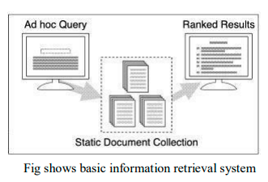

* A static, or relatively static, document collection is indexed prior to any user query.
* A query is issued and a set of documents that are deemed relevant to the query are ranked based on their computed similarity to the query and presented to the user query.
* Information Retrieval (IR) is devoted to finding relevant documents, not finding simple matches to patterns.
* A related problem is that of document routing or filtering. Here, the queries are static and the document collection constantly changes. An environment where corporate e-mail is routed based on predefined queries to different parts of the organization (i.e., e-mail about sales is routed to the sales department, marketing e-mail goes to marketing, etc.) is an example of an application of document routing.

Figure illustrates document routing

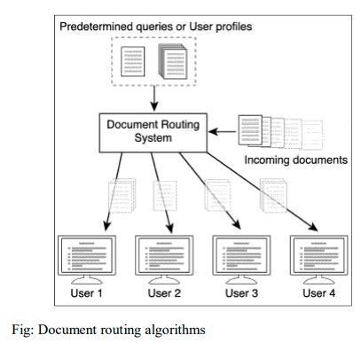

**Definition of Information Retrieval System**

* A system that is capable of **storage, retrieval, and maintenance of information**.
* Information can be composed of text (including numeric and date data), images, audio, video and other multi-media objects.
* consists of a software program that facilitates a user in finding the information the user needs.
* may use standard computer hardware or specialized hardware to support the search sub function and to convert non-textual sources to a searchable media (e.g., transcription of audio to text).
* Thus, search composition, search execution, and reading non-relevant items are all aspects of information retrieval overhead.

**Item**: The smallest complete unit that is processed and manipulated by the system is called an item. The definition of item varies by how a specific source treats information.

It is composed of text in the form of closed captioning, audio text provided by the speakers, and the video images being displayed.

Example: A book, Newspaper, magazine, video news program.

With the advent of inexpensive powerful personnel computer processing systems and high speed, large capacity secondary storage products, it has become commercially feasible to provide large textual information databases for the average user.

The introduction and exponential growth of the Internet along with its initial WAIS (Wide Area Information Servers) capability and more recently advanced search servers (e.g., INFOSEEK, EXCITE) has provided a new avenue for access to terabytes of information.

The algorithms and techniques to optimize the processing and access of large quantities of textual data were once the sole domain of segments of the Government, a few industries, and academics.

Images across the Internet are searchable from many web sites such as WEBSEEK, DITTO.COM, ALTAVISTA/IMAGES.

News organizations such as the BBC are processing the audio news they have produced and are making historical audio news searchable via the audio transcribed versions of the news.

Major video organizations such as Disney are using video indexing to assist in finding specific images in their previously produced videos to use in future videos or incorporate in advertising.

**Objectives of Information Retrieval Systems**

* To minimize the overhead of a user locating needed information.
* Overhead can be expressed as the time a user spends in all of the steps leading to reading an item containing the needed information.

Example:

query generation,

query execution,

scanning results of query to select items to read,

reading non-relevant items.

* In information retrieval, the term “relevant” item is used to represent an item containing the needed information.
* When a user decides to issue a search looking for information on a topic, the total database is logically divided into four segments.

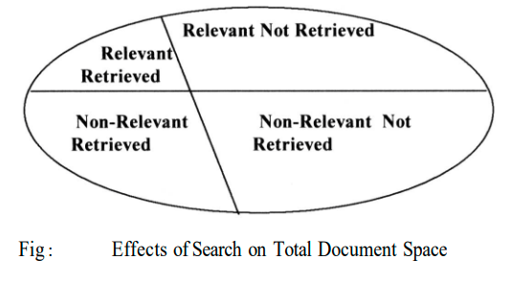

**Relevant items: Documents that contain information that helps the searcher in answering his question.**

**Non-relevant items: Items that do not provide any directly useful information.**

**Two possibilities with respect to each item:**

* **it can be retrieved**
* **not retrieved by the user’s query.**

The two major measures commonly associated with information systems are

* **Precision**
* **Recall**

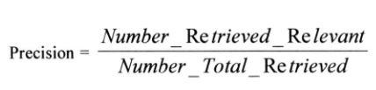

* Precision is directly affected by retrieval of non-relevant items
* thus, drops to a number close to zero.

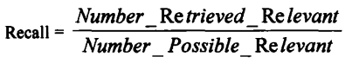

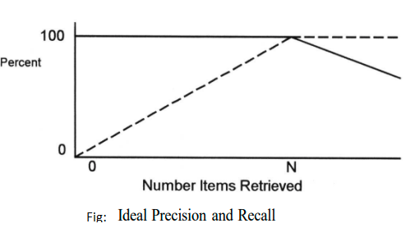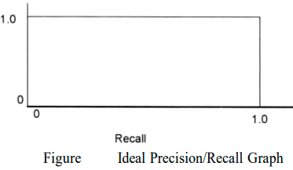

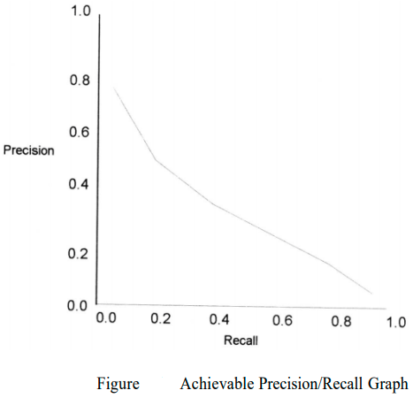

* Recall is not effected by retrieval of non-relevant items
* thus, remains at 100 percent efficiency once achieved.

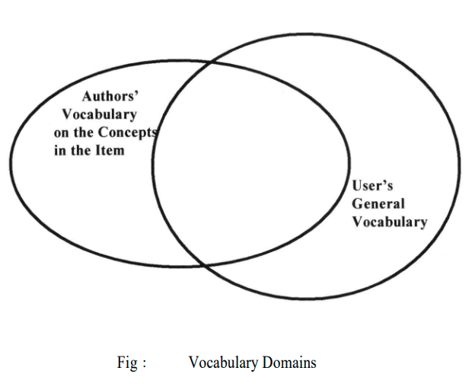

Natural language queries

* are becoming a standard system feature.
* allows users to state in natural language what they are interested in finding.
* the completeness of the user specification is limited by the user’s willingness to construct long natural language queries.
* Most users on the Internet enter one or two search terms.
* Examples of such Information Retrieval Systems are Retrieval Ware, TOPIC, AltaVista, Infoseek and INQUERY.

**Functional Overview**

A total Information Storage and Retrieval System is composed of four major functional processes:

1. **Item Normalization**
2. **Selective Dissemination of Information (i.e., “Mail”)**
3. **Archival Document Database Search, and an Index**
4. **Database Search along with the Automatic File Build process that supports Index Files.**
5. **Item Normalization**

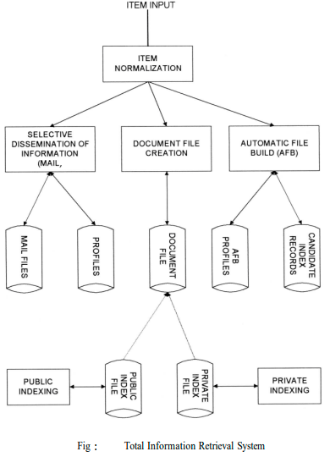

* Normalize incoming items to a standard format
* Language encoding
* Different file formats…
* Logical restructuring – zoning
* Create a searchable data structure (Indexing)
* Identification of processing tokens
* Characterization of the tokens – single words, or phrase
* Stemming of the tokens

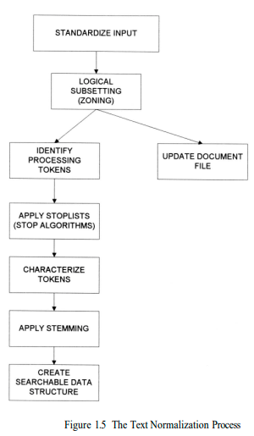

**Standardize Input**:

* Takes the different external formats of input data and performs the translation to the formats acceptable to the system.
* A system may have a single format for all items or allow multiple formats.

**Example of standardization**

* + Translation of foreign languages into Unicode.
  + Every language has a different internal binary encoding for the characters in the language.
  + One standard encoding that covers English, French, Spanish, etc. is ISO Latin.
  + To assist the users in generating indexes, especially the professional indexers, the system provides a process called Automatic File Build(AFB).
  + Multi-media adds an extra dimension to the normalization process.
  + In addition to normalizing the textual input, the multi-media input also needs to be standardized.
  + There are a lot of options to the standards being applied to the normalization.
  + If the input is video the likely digital standards will be either MPEG-2, MPEG-1, AVI or Real Media.
  + MPEG (Motion Picture Expert Group) standards are the most universal standards for higher quality video where Real Media is the most common standard for lower quality video being used on the Internet.
  + Audio standards are typically WAV or Real Media (Real Audio). Images vary
  + from JPEG to BMP.

**Logical sub setting or Zoning**

* parse the item into logical sub-divisions that have meaning to the user visible to the user and used to increase the precision of a search and optimize the display.
* A typical item is sub- divided into zones, which may overlap and can be hierarchical, such as Title, Author, Abstract, Main Text, Conclusion, and References.

**Token identification operation**

* The zoning information is passed to the processing token identification operation to store the information, allowing searches to be restricted to a specific zone.
* For example, if the user is interested in articles discussing “Einstein” then the search should not include the Bibliography, which could include references to articles written by “Einstein.”
* Systems determine words by dividing input symbols into 3 classes:
  + Valid word symbols
  + Inter-word symbols
  + Special processing symbols.
* word
  + is defined as a contiguous set of word symbols bounded by interword symbols.
  + Examples of word symbols are alphabetic characters and numbers.
* inter-word symbols
  + are non-searchable and should be carefully selected.
  + Examples of possible inter-word symbols are blanks, periods and semicolons.
  + The exact definition of an inter-word symbol is dependent upon the aspects of the language domain of the items to be processed by the system.
  + For example, an apostrophe may be of little importance if only used for the possessive case in English.

**Stop List/Algorithm**

* Save system resources by eliminating from the set of searchable processing tokens those have little value to the search Whose frequency and/or semantic use make them of no use as searchable token
* Any word found in almost every item
* Any word only found once or twice in the database
* **Frequency * Rank = Constant**
* applied to the list of potential processing tokens.
* The objective of the Stop function is to save system resources by eliminating from the set of searchable processing tokens those that have little value to the system.
* Given the significant increase in available cheap memory, storage and processing power, the need to apply the Stop function to processing tokens is decreasing.
* Examples of Stop algorithms are:
  + Stop all numbers greater than “999999”,
  + Stop any processing token that has numbers and characters intermixed.
* The algorithms are typically source specific, usually eliminating unique item numbers that are frequently found in systems and have no search value.

**Applying Stemming Algorithm**

* Once the potential processing token has been identified and characterized, most systems apply stemming algorithms to normalize the token to a standard semantic representation.
* The decision to perform stemming is a tradeoff between precision of a search (i.e., finding exactly what the query specifies) versus standardization to reduce system overhead in expanding a search term to similar token representations with a potential increase in recall.
* For example, the system must keep singular, plural, past tense, possessive, etc. as separate searchable tokens and potentially expand a term at search time to all its possible representations, or just keep the stem of the word, eliminating endings.
* The amount of stemming that is applied can lead to retrieval of many nonrelevant items.
* Some systems such as RetrievalWare, that use a large dictionary/thesaurus, looks up words in the existing dictionary to determine the stemmed version in lieu of applying a sophisticated algorithm.

**Create Searchable data structure**

* Once the processing tokens have been finalized, based upon the stemming algorithm, they are used as updates to the searchable data structure.
* The searchable data structure is the internal representation (i.e., not visible to the user) of items that the user query searches.
* This structure contains the semantic concepts that represent the items in the database and limits what a user can find as a result of their search.
* When the text is associated with video or audio multi-media, the relative time from the start of the item for each occurrence of the processing token is needed to provide the correlation between the text and the multi-media source.

1. **Selective Dissemination of Information**

* provides the capability to dynamically compare newly received items in the information system against standing statements of interest of users
* deliver the item to those users whose statement of interest matches the contents of the item.
* composed of the
  + search process,
  + user statements of interest (Profiles)
  + user mail files.
* As each item is received, it is processed against every user’s profile.
* A profile contains a typically broad search statement along with a list of user mail files that will receive the document if the search statement in the profile is satisfied.
* Selective Dissemination of Information has not yet been applied to multimedia sources.

1. **Document Database Search**

* provides the capability for a query to search against all items received by the system.
* composed of the search process, user entered queries (typically ad hoc queries) and the document database which contains all items that have been received, processed and stored by the system.
* Typically, items in the Document Database do not change (i.e., are not edited) once received.

1. **Index Database Search**

* user can logically store an item in a file along with additional index terms and descriptive text the user wants to associate with the item for future reference.
* provides the capability to create indexes and search them.
* index files are of two classes:
  + Public Index files
  + Private Index files
* Private Index files
  + Every user can have one or more private Index files leading to a very large number of files.
  + Each Private Index file references only a small subset of the total number of items in the Document Database.
  + Private Index files typically have very limited access lists.
* Public Index files
  + maintained by professional library services personnel
  + typically index every item in the Document Database.
  + There is a small number of Public Index files.
  + These files have access lists (i.e., lists of users and their privileges) that allow anyone to search or retrieve data.
  + To assist the users in generating indexes, especially the professional indexers, the system provides a process called Automatic File Build shown (also called Information Extraction).

**Multimedia Database Search**

* From a system perspective, the multi-media data is not logically its own data structure, but an augmentation to the existing structures in the Information Retrieval System.

**Relationship to Database Management Systems**

* There are two major categories of systems available to process items:
  + Information Retrieval Systems and
  + Data Base Management Systems (DBMS).
* An Information Retrieval System is software that has the features and functions required to manipulate “information” items versus a DBMS that is optimized to handle “structured” data.
* Structured data is well defined data (facts) typically represented by tables. There is asemantic description associated with each attribute within a table that well defines that attribute. For example, there is no confusion between the meaning of “employee name” or “employee salary” and what values to enter in a specific database record. On the other hand, if two different people generate an abstract for the same item, they can be different. One abstract may generally discuss the most important topic in an item. Another abstract, using a different vocabulary, may specify the details of many topics. It is this diversity and ambiguity of language.
* With structured data a user enters a specific request and the results returned provide the user with the desired information. The results are frequently tabulated and presented in a report format for ease of use. In contrast, a search of “information” items has a high probability of not finding all the items a user is looking for. The user has to refine his search to locate additional items of interest. This process is called “iterative search.
* From a practical standpoint, the integration of DBMS’s and Information Retrieval Systems is very important. Commercial database companies have already integrated the two types of systems. One of the first commercial databases to integrate the two systems into a single view is the INQUIRE DBMS.

**Digital Libraries and Data Warehouses**

* Two other systems frequently described in the context of information retrieval are,
  + Digital Libraries and
  + Data Warehouses (or Data Marts).
* There is a significant overlap between these two systems and an Information Storage and Retrieval System. All three systems are repositories of information and their primary goal is to “satisfy user information needs”
* As such, libraries have always been concerned with storing and retrieving information in the media it is created on. As the quantities of information grew exponentially, libraries were forced to make maximum use of electronic tools to facilitate the storage and retrieval process. With the worldwide interneting of libraries and information sources (e.g., publishers, news agencies, wire services, radio broadcasts) via the Internet, more focus has been on the concept of an electronic library.
* Indexing is one of the critical disciplines in library science and significant effort has gone into the establishment of indexing and cataloging standards. Migration of many of the library products to a digital format introduces both opportunities and challenges. The full text of items available for search makes the index process.
* Another important library service is a source of search intermediaries to assist users in finding information.
* Information Storage and Retrieval technology has addressed a small subset of the issues associated with Digital Libraries. The focus has been on the search and retrieval of textual data with no concern for establishing standards on the contents of the system.

**Information Retrieval System Capabilities: Search Capabilities, Browse Capabilities, Miscellaneous Capabilities**

Information Retrieval System Capabilities

* **Search Capabilities**
* **Browse Capabilities**
* **Miscellaneous Capabilities**
* **Standards**

The search capabilities address both Boolean and Natural Language queries. The algorithms used for searching are called Boolean, natural language processing and probabilistic.

Probabilistic algorithms use frequency of occurrence of processing tokens (words) in determining similarities between queries and items and also in predictors on the potential relevance of the found item to the searcher.

The newer systems such as TOPIC, Retrieval Ware, and INQUERY all allow for natural language queries.

Browse functions to assist the user in filtering the search results to find relevant information are very important.

**Search Capabilities**

* The objective of the search capability is to allow for a mapping between a user’s specified need and the items in the information database that will answer that need. It can consist of natural language text in composition style and/or query terms (referred to as terms in this book) with Boolean logic indicators between them.
* One concept that has occasionally been implemented in commercial systems (e.g., Retrieval Ware), and holds significant potential for assisting in the location and ranking of relevant items, is the “weighting” of search terms. This would allow a user to indicate the importance of search terms in either a Boolean or natural language interface.
* Given the following natural language query statement where the importance of a particular search term is indicated by a value in parenthesis () between 0.0 and 1.0 with 1.0 being the most important.
* The search statement may apply to the complete item or contain additional parameters
* limiting it to a logical division of the item (i.e., to a zone).
* Based upon the algorithms used in a system many different functions are associated with the system’s understanding the search statement.
* The functions define the relationships between the terms in the search statement (e.g., Boolean, Natural Language, Proximity, Contiguous Word Phrases, and Fuzzy Searches) and the interpretation of a particular word (e.g., Term Masking, Numeric and Date Range, Contiguous Word Phrases, and Concept/Thesaurus expansion).

**Boolean Logic**

* Boolean logic allows a user to logically relate multiple concepts together to define what information is needed.
* Boolean operators are AND, OR, and NOT.
* These operations are implemented using

set intersection,

set union and

set difference procedures.

* A search terms in either a Boolean or natural language interface.
* Given the following natural language query statement where the importance of a particular search term is indicated by a value in parenthesis between 0.0 and 1.0 with 1.0 being the most important.
* The search statement may apply to the complete item or contain additional parameters limiting it to a logical division of the item (i.e., to a zone) search terms in either a Boolean or natural language interface.
* Given the following natural language query statement where the importance of a particular search term is indicated by a value in parenthesis between 0.0 and 1.0 with 1.0 being the most important.
* Based upon the algorithms used in a system many different functions are associated with the system’s understanding the search statement.
* The functions define the relationships between the terms in the search statement (e.g., Boolean, Natural Language, Proximity, Contiguous Word Phrases, and Fuzzy Searches) and the interpretation of a particular word (e.g., Term Masking, Numeric and Date Range, Contiguous Word Phrases, and Concept/Thesaurus expansion).
* Few systems introduced the concept of “exclusive or” but it is equivalent to a slightly more complex query using the other operators and is not generally useful to users since most users do not understand it.
* A special type of Boolean search is called “M of N” logic. The user lists a set of possible
* search terms and identifies, as acceptable, any item that contains a subset of the terms. For example,
* “Find any item containing any two of the following terms: “AA,” “BB,” “CC.” This can be expanded into a Boolean search that performs an AND between all combinations of two terms and “OR”s the results together ((AA AND BB)or (AA AND CC) or (BB AND CC))

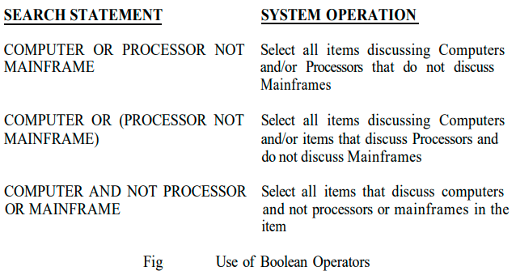

**Proximity**

* Proximity is used to restrict the distance allowed within an item between two search terms.
* The semantic concept is that the close search terms in either a Boolean or natural language interface.
* Given the following natural language query statement where the importance of a particular search term is indicated by a value in parenthesis between 0.0 and 1.0 with 1.0 being the most important.
* The search statement may apply to the complete item or contain additional parameters limiting it to a logical division of the item (i.e., to a zone).
* Based upon the algorithms used in a system many different functions are associated with the system’s understanding the search statement.
* The functions define the relationships between the terms in the search statement (e.g., Boolean, Natural Language, Proximity, Contiguous Word Phrases, and Fuzzy Searches) and the interpretation of a particular word (e.g., Term Masking, Numeric and Date Range, Contiguous Word Phrases, and Concept/Thesaurus expansion).
* Two terms are found in a text the more likely they are related in the description of a particular concept.
* Proximity is used to increase the precision of a search.
* If the terms COMPUTER and DESIGN are found within a few words of each other than the item is more likely to be discussing the design of computers than if the words are paragraphs apart. The typical format for proximity is:
  + TERM1 within “m” “units” of TERM2
* The distance operator “m” is an integer number and units are in Characters, Words, Sentences, or Paragraphs.
* A special case of the Proximity operator is the Adjacent (ADJ) operator that normally has a distance operator of one and a forward only direction (i.e., in WAIS).
* Another special case is where the distance is set to zero meaning within the same semantic unit. 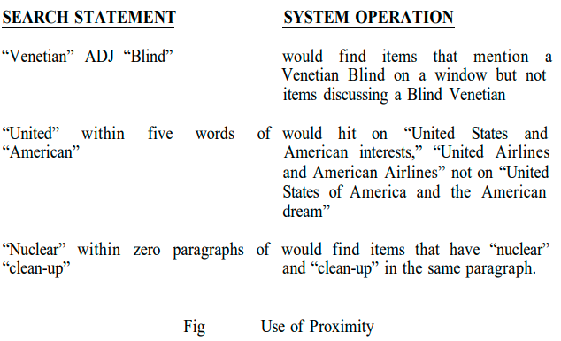

**Contiguous Word Phrases**

* A Contiguous Word Phrase (CWP) is both a way of specifying a query term and a special search operator. A Contiguous Word Phrase is two or more words that are treated as a single semantic unit.
* An example of a CWP is “United States of America.” It is four words that specify a search term representing a single specific semantic concept (a country) that can be used with any of the operators discussed above.
* Thus, a query could specify “manufacturing” AND “United States of America” which returns any item that contains the word “manufacturing” and the contiguous words “United States of America.”
* A contiguous word phrase also acts like a special search operator that is similar to the proximity (Adjacency) operator but allows for additional specificity. If two terms are specified, the contiguous word phrase and the proximity operator using directional one-word parameters or the Adjacent operator are identical.
* For contiguous word phrases of more than two terms the only way of creating an equivalent search statement using proximity and Boolean operators is via nested Adjacencies which are not found in most commercial systems.
* This is because Proximity and Boolean operators are binary operators but contiguous word phrases are an “N”ary operator where “N” is the number of words in the CWP.
* Contiguous Word Phrases are called Literal Strings in WAIS and Exact Phrases in RetrievalWare.
* In WAIS multiple Adjacency (ADJ) operators are used to define a Literal String (e.g., “United” ADJ “States” ADJ “of” ADJ “America”).

**Fuzzy Searches**

* Fuzzy Searches provide the capability to locate spellings of words that are similar to the entered search term.
* This function is primarily used to compensate for errors in spelling of words. Fuzzy
* searching increases recall at the expense of decreasing precision (i.e., it can erroneously identify terms as the search term).
* In the process of expanding a query term fuzzy searching includes other terms that have similar spellings, giving more weight (in systems that rank output) to words in the database that have similar word lengths and position of the characters as the entered term.
* A Fuzzy Search on the term “computer” would automatically include the following words from the information database: “computer,” “computer,” “computer,” “computer,” “compute.”

**Term Masking**

* Term masking is the ability to expand a query term by masking a portion of the term and accepting as valid any processing token that maps to the unmasked portion of the term.
* The value of term masking is much higher in systems that do not perform stemming or only provide a very simple stemming algorithm.
* There are two types of search term masking:
  + fixed length and
  + variable length.
* Sometimes they are called fixed and variable length “don’t care” functions.
* Fixed length masking is a single position mask. It masks out any symbol in a particular
* position or the lack of that position in a word.
* Variable length “don’t care” allows masking of any number of characters within a processing token.
* The masking may be in the front, at the end, at both front and end, or imbedded.
* The first three of these cases are called suffix search, prefix search and imbedded character string search, respectively.
* The use of an imbedded variable length doesn’t care is seldom used.
* If “*” represents a variable length don’t care then the following are examples of its use:
* Figure provides examples of the use of variable length term masking.

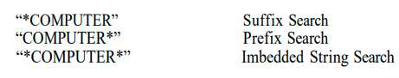

**Numeric and Date Ranges**

* Term masking is useful when applied to words, but does not work for finding ranges of numbers or numeric dates.
* To find numbers larger than “125,” using a term “125*” will not find any number except those that begin with the digits “125.”

**Concept/Thesaurus Expansion**

* Associated with both Boolean and Natural Language Queries is the ability to expand the search terms via Thesaurus or Concept Class database reference tool.
* A Thesaurus is typically a one-level or two-level expansion of a term to other terms that are similar in meaning.
* A Concept Class is a tree structure that expands each meaning of a word into potential concepts that are related to the initial term (e.g., in the TOPIC system).
* Concept classes are sometimes implemented as a network structure that links word stems (e.g., in the Retrieval Ware system).

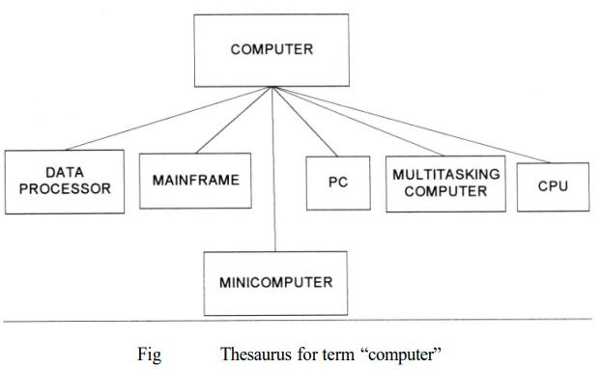

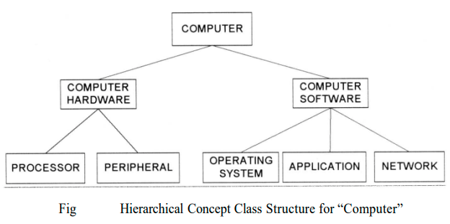

* Thesauri are either semantic or based upon statistics. A semantic thesaurus is a listing of words and then other words that are semantically similar.
* The problem with thesauri is that they are generic to a language and can introduce many search terms that are not found in the document database.
* An alternative uses the database or a representative sample of it to create statistically related terms. It is conceptually a thesaurus in that words that are statistically related to other words by their frequently occurring together in the same items.
* This type of thesaurus is very dependent upon the database being searched and may not be portable to other databases.

**Natural Language Queries**

Natural language interfaces improve the recall of systems with a decrease in precision when negation is required.

**Browse Capabilities**

* Once the search is complete, browse capabilities provide the user with the capability to determine which items are of interest and select those to be displayed.
* There are two ways of displaying a summary of the items that are associated with a query:
  + line item status and
  + data visualization.
* From these summary displays, the user can select the specific items and zones within the items for display.

**Ranking**

* Typically, relevance scores are normalized to a value between 0.0 and 1.0.
* The highest value of 1.0 is interpreted that the system is sure that the item is relevant to the search statement.
* In addition to ranking based upon the characteristics of the item and the database, in many circumstances collaborative filtering is providing an option for selecting and ordering output.
* Collaborative filtering has been very successful in sites such as AMAZON.COM MovieFinder.com, and CDNow.com in deciding what products to display to users based upon their queries. Rather than limiting the number of items that can be assessed by the number of lines on a screen, other graphical visualization techniques showing the relevance relationships of the hit items can be used.
* For example, a two- or three-dimensional graph can be displayed where points on the graph represent items and the location of the points represent their relative relationship between each other and the user’s query. In some cases, color is also used in this representation.
* This technique allows a user to see the clustering of items by topics and browse through a cluster or move to another topical cluster.

**Zoning**

Related to zoning for use in minimizing what an end user needs to review from a hit item is the idea of locality and passage-based search and retrieval.

**Highlighting**

* Most systems allow the display of an item to begin with the first highlight within the item and allow subsequent jumping to the next highlight.
* The DCARS system that acts as a user frontend to the Retrieval Ware search system allows the user to browse an item in the order of the paragraphs or individual words that contributed most to the rank value associated with the item.
* The highlighting may vary by introducing colors and intensities to indicate the relative importance of a particular word in the item in the decision to retrieve the item.

**Miscellaneous Capabilities**

**Vocabulary Browse**

* Vocabulary Browse provides the capability to display in alphabetical sorted order words from the document database. Logically, all unique words (processing tokens) in the database are kept in sorted order along with a count of the number of unique items in which the word is found. The user can enter a word or word fragment and the system will begin to display the dictionary around the entered text.
* It helps the user determine the impact of using a fixed or variable length mask on a search term and potential mis-spellings. The user can determine that entering the search term “compile*” in effect is searching for “compulsion” or “compulsive” or “compulsory.” It also shows that someone probably entered the word “compute” when they really meant “computer.”

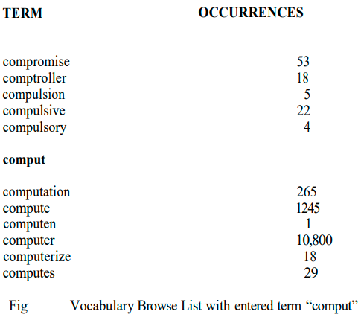

**Iterative Search and Search History Log**

* Frequently a search returns a Hit file containing many more items than the user wants to review.
* Rather than typing in a completely new query, the results of the previous search can be used as a constraining list to create a new query that is applied against it. This has the same effect as taking the original query and adding additional search statement against it in an AND condition.
* This process of refining the results of a previous search to focus on relevant items is called iterative search. This also applies when a user uses relevance feedback to enhance a previous search. The search history log is the capability to display all the previous searches that were executed during the current session.

**Canned Query**

* The capability to name a query and store it to be retrieved and executed during a later user session is called canned or stored queries. A canned query allows a user to create and refine a search that focuses on the user’s general area of interest one time and then retrieve it to add additional search criteria to retrieve data that is currently needed.
* Canned query features also allow for variables to be inserted into the query and bound to specific values at execution time.

**Standards ( Z39.50 and WAIS )**

**Z39.50 :**

* The Z39.50 standard does not specify an implementation, but the capabilities withinan application(Application Service) and the protocol used to communicate between applications (Information Retrieval Application Protocol).
* It is a computer-to-computer communications standard for database searching and record retrieval. Its objective is to overcome different system incompatibilities associated with multiple database searching.
* The first version of Z39.50 was approved in 1992. An international version of Z39.50, called the Search and Retrieve Standard (SR), was approved by the International Organization for Standardization (ISO) in 1991. Z39.50-1995, the latest version of Z39.50, replaces SR as the international information retrieval standard. The standard describes eight operation types: Init (initialization), Search, Present, Delete, Scan, Sort, Resource-report, and Extended Services. There are five types of queries (Types 0, 1, 2, 100, 101, and 102).
* The client is identified as the “Origin” and performs the communications functions relating to initiating a search, translation of the query into a standardized format, sending a query, and requesting return records.
* The server is identified as the “Target” and interfaces to the database at the remote responding to requests from the Origin (e.g., pass query to database, return records in a standardized format and status). The end user does not have to be aware of the details of the standard since the Origin function performs the mapping from the user’s query interface into Z39.50 format.
* This makes the dissimilarities of different database systems transparent to the user and facilitates issuing one query against multiple databases at different sites returning to the user a single integrated Hit file.

**Wide Area Information Service (WAIS)**

* Wide Area Information Service (WAIS) is the de facto standard for many search environments on the INTERNET. WAIS was developed by a project started in 1989 by three commercial companies (Apple, Thinking Machines, and Dow Jones).
* The original idea was to create a program that would act as a personal librarian.
* A free version of WAIS is still available via the Clearinghouse for Networked Information Discovery and Retrieval (CINDIR) called “FreeWAIS.” The originaldevelopment of WAIS started with the 1988 Z39.50 protocol as a base following the client/server architecture concept.
* The developers incorporated the information retrieval concepts that allow for ranking, relevance feedback and natural language processing functions that apply to full text searchable databases.
* Center for National Research Initiatives (CNRI) that is working with the Department of Defense and also the American Association of Publishers (AAP), focusing on an Internet implementation that allows for control of electronic published and copyright material.
* In addition to the Handle Server architecture, CNRI is also advocating a communications protocol to retrieve items from existing systems.
* This protocol call Repository Archive Protocol (RAP) defines the mechanisms for clients to use the handles to retrieve items. It also includes other administrative functions such as privilege validation.
* The Handle system is designed to meet the Internet Engineering Task Force (IETF) requirements for naming Internet objects via Uniform Resource Names to replace URLs as defined in the Internet’s RFC-1737 (IETF- 96).
* WAIS (Wide Area Information Servers) is an Internet system in which specialized subject databases are created at multiple server locations, kept track of by a directory of servers at one location, and made accessible for searching by users with WAIS client programs.
* The user of WAIS is provided with or obtains a list of distributed database s. The user enters a search argument for a selected database and the client then accesses all the servers on which the database is distributed.
* The results provide a description of each text that meets the search requirements. The user can then retrieve the full text.
* Retrieval Ware is an enterprise search engine emphasizing natural language processing and semantic network